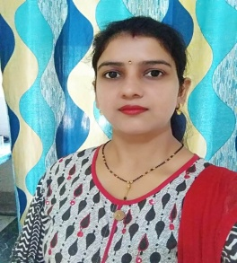
1. "The Best of all things is to "LEARN"... Money can be lost or stolen, Health and strength may be fallen... But what you LEARN from your TEACHERS in a school or college is Yours forever..." And Saraswati Mahila Mahavidyalaya is one of the Best colleges which grows/blooms a lot of Independent & Inspirational personalities in the Guidance & with the invaluable Support of its Best Teachers... I thank to all my Respected Teachers from the bottom of my Heart for Enlightening My path forever...

Pooja
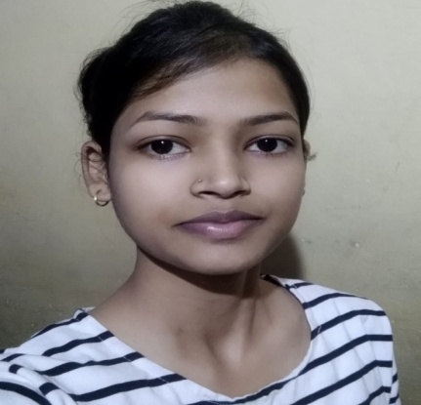
Govt. Teacher in MMS Nagina

2. Firstly, Saraswati Mahila Mahavidyalaya is not a college, it is a brand. It is unique in its field. Discipline is like in the air of its environment. SM M gave me a platform that I will cherish always. Some days I won and some days I learned. I am so grateful to be a part of this college. There are so many opportunities to develop one’s personality in any field like, cultural, literature and many more. It was very precious and golden phase of my life. Right from being top the university in my 1st semester exams to The Student Of Year (18-19), Smm always held my back. The entire faculty and other members of this institution are very cooperative. I got a lot of love and support from my teachers & colleague and it made my 3 yrs. memorable for me.

Sapna
(2015-2018)
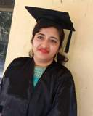
3. One of the finest institution in Haryana specially for girls with carrier oriented courses along with graduates and postgraduate programmes to help them shaping their carrier in their own way..

Ruchika Chhabra
Assistant Professor in math
Aggarwal PG college Ballabhgarh
Bsc cs(2005-2008)

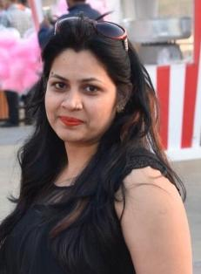
4. Firstly, SMM College is not a college, it is a brand. It is unique in its field. Discipline is like in the air of its environment. I am so grateful to be a part of this college. There are so many opportunities to develop one‟s personality in any field like, cultural, literature and many more. It was very precious and golden phase of my life. The entire faculty( special thanks for preeti mam ,shikha mam ,Nisha mam,Jyoti mam) and other members of this college are very cooperative. I got a lot of love and support from my teachers & colleague and it made my 5 year(B.Sc & M.Sc)memorable for me.

Suman Malik
Associative Professor in Physics
Fiitjee Ltd Co.

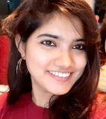
5. सीखा था जहाँ सपने बुनना,वो है SMM
भरी थी उड़ाने नयी जहाँ, वो है SMM
कभी हार कर कभी जीत कर,
जहाँ अद्भूत समय बिताया है
प्रेरणा विश्वास का, वो समावेश है SMM

Manisha Dixit
Research Scholar,
Department of Physics IIT(BHU), Varanasi,
221005,Uttarpardesh
Bsc (N.M) (2011-2014)

महाविद्यालय में बिताये वो 3 साल मेरे बहुत सारे सपनों और आत्मविश्वास का आधार हैं। जो ख्वाब वहाँ पाला था,आज IIT में शोधार्थी बन काम करके,उसे पूरा करने की भरपूर कोशिश कर रही हूँ! सदैव आभारी रहूँगी उन सभी की,जिन्होनें जताया भरोसा और हमेशा मार्गदर्शन किया! SMM हमारे इलाके में एक वरदान की तरह है
हर वो लड़की जो अपनी नेक नीयत और सकारात्मक तौर तरीके से यहाँ सपनों को पूरा करने आयेगी,मैं समझती हूँ कि फिर आपको कोई नहीं रोक सकता!!
सरस्वती महाविद्यालय परिवार को ढ़ेर ढ़ेर शुभकामनाएँ और बहुत सारा प्रेम!!

6. saraswati mahila mahavidyalaya is the best college of M.d.u for girl.this college has its own character which shown its students.This college gives us not only educational knowlege but social also .most of old students still connected this college .so we can guess the connection between the teachers n students.I have won many prizes during my session in this college.I have no words to say thanks my all lovely teachers. my college life is priceless n unforgettable in this college...thank you so much S.M.M

Sapna saini
Business women and a poetess on nojoto
7. What a priviledge it is to be a part of such an amazing institution, filled with such amazing Teachers !
I have received the greatest benefit of anything I can imagine from my studies. I cannot imagine any possible way to truly express my thanks but want to say "Not all superheroes wear capes, some having teaching degrees"

Naina sanduja
Underwriting analyst
at Xceedance consulting pvt Ltd, Gurgaon.
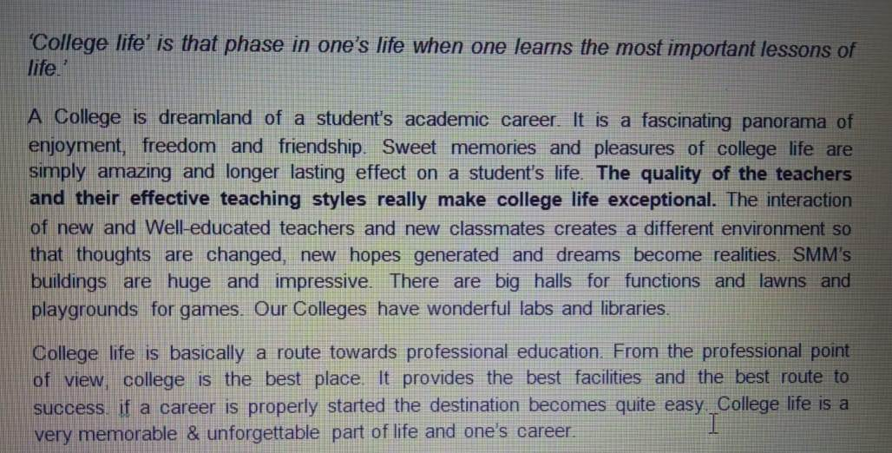

Neelima HOD-human resource doctor IVF and multispeciality hospital fbd.

